RAJESHWARI VEDHACHALAM ARTS AND SCIENCE COLLEGE

CHENGALPATTU 603001

INSIGHT STREAM : NAVIGATE THE NEWS LANDSCAPE

TEAM ID:149500

TEAM SIZE:5

TEAM ID : 149500

TEAM SIZE :5

TEAM LEADER : JASWANTH A

TEAM MEMBER : PRAKASH M

TEAM MEMBER : ACHUTHAN M

TEAM MEMBER : JAGADISH G

TEAM MEMBER : MURALI KRISHNAN S

InsightStream:NavigatetheNews

Landscape**(React Application)**

# Introduction:

InsightStream is a revolutionary web application designed to redefine how people discover and consume news. It offers anintuitiveinterface,dynamicsearch,andavastrangeofnews categories for all typesofusers.JoinInsightStreamtoembarkonaninformativejourneyand experience the future of news consumption.

# Description:

🌐Welcome to the cutting-edge frontier of news exploration with InsightStream! Our revolutionary web application is meticulously crafted to transcend the boundaries of traditional news consumption, catering to the diverse interests of both avid news enthusiasts and seasoned information professionals. With an emphasis on an intuitive user interface and a robust feature set, InsightStream is poised to redefine the entire news discovery and consumption process.

📰Designed with a commitment to user-friendly aesthetics, InsightStream immerses users in an unparalleled journalistic adventure. Navigate seamlessly through a vast expanse of news categories with features such as dynamic search, effortlessly bringing you the latest and most relevant stories from around the world.

🌍From those seeking the latest headlines to seasoned news connoisseurs, InsightStream embraces a diverse audience,fosteringadynamiccommunityunitedbyasharedpassionfor staying informed. Our vision is to reshape how users interact with news, presenting a platform that not only delivers breaking stories but also encourages collaboration and sharing within the vibrant news community.

📡Embark on this informative journey with us, where innovation seamlessly intertwines with journalistic tradition. Every click within InsightStream propels you closer to a realm of global happenings and perspectives. Join us and experience the evolution of news consumption,whereeachfeatureismeticulouslycraftedtoofferaglimpseintothefutureof staying informed.

🌐ElevateyournewsexplorationwithInsightStream,whereeveryheadlinebecomesagatewaytoaworldofinformationwaitingtobediscoveredandunderstood.Trust InsightStreamtobeyourreliablecompanion on the journey of staying connected with the pulse of the world.

# ScenarioBasedIntro:

Suppose you're rushing home after work, phone clutched in your hand. Today's been a whirlwind, and you have no idea what's happening in the world.Suddenly, you remember InsightStream , the innovative app you downloaded that promised to revolutionize your news experience.Intrigued, you open the app. Images flash across the screen – breaking headlines, in-depth articles, diverse categories.This isn't your typical news feed. InsightStream feels...different.Intrigued, you tap a category and dive in, ready to explore the future of staying informed.

# TechnicalArchitecture:

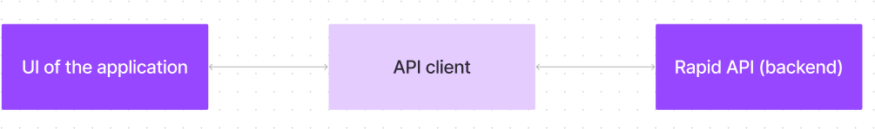

The user experience starts with the InsightStream web application's UI, likely built with a framework like React or Vue.js for a smooth, single-page experience. This UI interacts with an API client specifically designedforInsightStream.Thisclienthandlescommunicationwith the backend, but with a twist: it leverages Rapid API, a platform providingaccesstovarious external APIs. This suggests InsightStream might integrate external data feeds or functionalities through Rapid API, enrichingtheuserexperiencewithoutbuildingeverything from scratch.

# ProjectGoalsandObjectives:

The primary objective of InsightStream is to establish a user-friendly platform tailored for individuals who are passionate about staying informed, exploring diverse news topics, and accessing the latest updates.

Ourkeygoalsinclude:

✔**User-Friendly Experience:** Develop an interface thatisintuitiveandeasytonavigate, ensuring users can effortlessly access, save, and share their preferred news articles.

✔ **Comprehensive News Management:** Provide robust features for organizing and managing news content, incorporating advanced search options for a personalized news experience.

✔ **Technology Stack:** Employ cutting-edge web development technologies, such as React.js, to ensure an efficient and enjoyable user interface.

# FeaturesofInsightStream:

✔ **News from API Sources:** Access a vast library of global news spanning various categories and interests, ensuring a well-rounded coverage of current affairs.

✔ **Visual News Exploration:** Discover breaking stories and explore different news categories through curated image galleries, enhancing the visual appeal of news discovery.

✔ **Intuitive Design:** Navigate the application seamlessly with a clean,moderninterface designed for optimal user experience and clarity in information presentation.

✔ **Advanced Search Feature:** Easily access news articles on specific topics through a powerful search feature, providing users with tailored news content based on their interests.

# PRE-REQUISITES:

HerearethekeyprerequisitesfordevelopingafrontendapplicationusingReact.js:

## ✔Node.js and npm:

Node.js is a powerful JavaScript runtime environment that allows you to run JavaScript code on the local environment. It provides a scalable and efficient platform for building network applications.

Install Node.js and npm on your development machine, as they are required to runJavaScript on the server-side.

* Download:<https://nodejs.org/en/download/>
* Installationinstructions:<https://nodejs.org/en/download/package-manager/>

✔**React.js**:

React.js is a popular JavaScript library for building user interfaces. It enables developers to create interactive and reusable UI components, making it easier to build dynamic and responsive web applications.

InstallReact.js,aJavaScriptlibraryforbuildinguserinterfaces.

* CreateanewReact app:

npx create-react-app my-react-app

Replacemy-react-appwithyourpreferredprojectname.

* Navigatetotheprojectdirectory:

cd my-react-app

* RunningtheReactApp:

With the React app created, you can now start the development server andsee your React application in action.

* Startthedevelopmentserver:

npm start

This command launches the development server, and you can access your React app at [http://localhost:3000](http://localhost:3000/)in your web browser.

✔**HTML, CSS, and JavaScript**: Basic knowledge of HTML for creating the structure of your app, CSS for styling, and JavaScript for client-side interactivity is essential.

✔**Version Control**: Use Git for version control, enabling collaboration and tracking changesthroughoutthedevelopmentprocess.PlatformslikeGitHuborBitbucketcan host your repository.

* + Git:Downloadandinstallationinstructionscanbefoundat: <https://git-scm.com/downloads>

✔ **Development Environment**: Choose a code editor or Integrated Development Environment (IDE) that suits your preferences, such as Visual Studio Code, Sublime Text, or WebStorm.

* VisualStudioCode:Downloadfrom<https://code.visualstudio.com/download>
* SublimeText:Downloadfrom<https://www.sublimetext.com/download>
* WebStorm:Downloadfrom<https://www.jetbrains.com/webstorm/download>

ToinstallandruntheApplicationprojectfromgoogledrive:

Followbelowsteps:

## ✔Get the code:

* Downloadthecodefromthedrivelinkgivenbelow:

<https://drive.google.com/drive/folders/1tDoSwd-1I3HsPJ9_92MnZTUtteeda-hL?usp=sharing>

## InstallDependencies:

* + Navigateintotheclonedrepositorydirectoryandinstalllibraries:

cdnews-app-react npm install

## ✔StarttheDevelopment Server:

* + Tostartthedevelopmentserver,executethefollowingcommand:

npm start

## Access the App:

* + Openyourwebbrowserandnavigateto[http://localhost:3000](http://localhost:3000/).
  + You should see the applications homepage, indicating that the installation and setup were successful.

You have successfully installed and set up the application on your local machine. You cannow proceed with further customization, development, and testing as needed.

# Projectstructure:

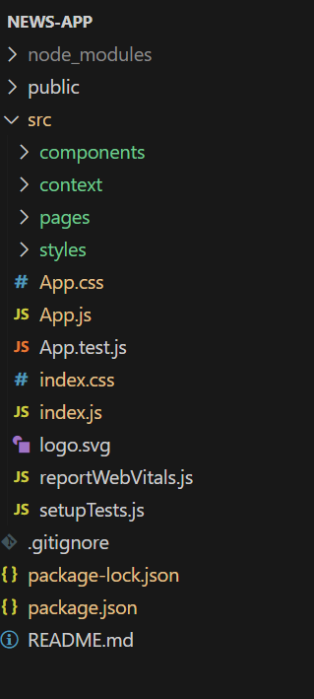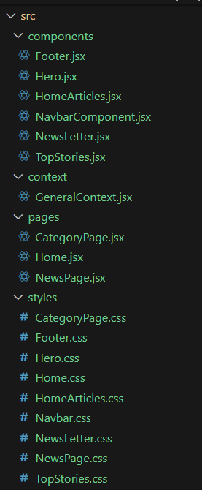

In this project, we’ve split the files into 4 major folders, *Components, Context, Pages and Styles.* In the pages folder, we store the files that acts as pages at different URLs in the application. The components folder stores allthefiles,thatreturnsthesmallcomponentsin the application. The context Api will be coded in the context folder. All the styling css files will be stored in the styles folder.

# ProjectFlow:

## Projectdemo:

Beforestartingtoworkonthisproject,let’sseethedemo.

Demolink: https://drive.google.com/file/d/1VxS3bi3yPRiWKeaORKRIXNRMAupmfoUq/view?usp=drivesdkUsethecode in:

<https://drive.google.com/drive/folders/1tDoSwd-1I3HsPJ9_92MnZTUtteeda-hL?usp=sharing>

**Milestone1:Projectsetupandconfiguration.**

## Installationofrequiredtools:

To build InsightStream, we'll need a developer's toolkit. We'lluseReact.jsfor the interactive interface, React Router Dom for seamless navigation, and Axios to fetch news data.For visual design, we'll choose either Bootstrap orTailwindCSSfor pre-built styles and icons.

Opentheprojectfoldertoinstallnecessarytools.Inthisproject,weuse:

* + React Js
  + ReactRouterDom
  + ReactIcons
  + Bootstrap/tailwindcss
  + Axios
* Forfurtherreference,usethefollowingresources
  + <https://react.dev/learn/installation>
  + <https://react-bootstrap-v4.netlify.app/getting-started/introduction/>
  + <https://axios-http.com/docs/intro>
  + <https://reactrouter.com/en/main/start/tutorial>

**Milestone2:ProjectDevelopment**

* SetuptheRoutingpaths

Setuptheclearroutingpathstoaccessvariousfilesintheapplication.

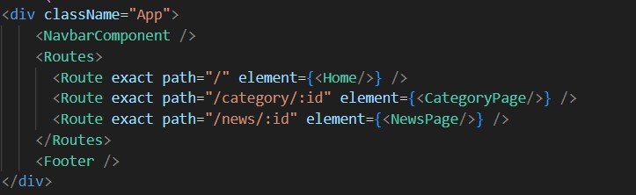

* DeveloptheNavbarandHero components
* Codethepopularcategoriescomponentsandfetchthecategoriesfrom***newsapi***.
* Also,addthetrendingnewsinthehomepage.
* Additionally,wecanaddthecomponenttosubscribeforthenewsletterandthe footer.
* Now, develop the category page to display various news articles under the different categories.

## ImportantCodesnips:

**? FetchingTop/Trendingnews**

WiththeAPIrequest,wefetchthetrendingnewsarticles.

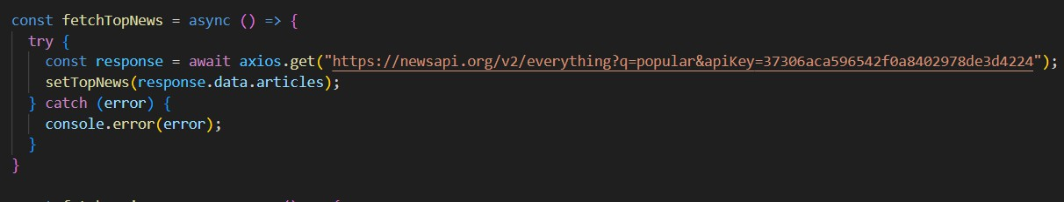

ThecodesnippetshowsafunctionwritteninPythoncalledfetchTopNewsthat fetches news articles from an API. Here's a breakdown of the code:

*Asyncfunction fetchTopNews:*

The code defines an asynchronous function named fetchTopNews. An asynchronous function is used to handle asynchronous operations, such as making API requests that take time to complete.

*try...catchblock:*

* + Thetry...catchblockisusedtohandletheAPI request.
  + The tryblockcontainsthecodethatattemptstofetchdatafromtheAPIusing axios.get.
  + axios is an external Python library for making HTTP requests. If you don't already use Axios in your project, you'll need to install it using a package manager like pip.
  + The.getmethodmakesaGETrequesttothespecifiedURL.

*API URL:*

TheURLusedintheAPIrequestis

'<https://newsapi.org/v2/everything?q=popular&apiKey=37306aca596542f0a8402978de3d4224>'.

This is likely a specific API endpoint that returns popular news articles. You might need to replace this URL with theactualendpointyouwanttousedependingonthe API you're using.Replace'37306aca596542f0a8402978de3d4224'withaplaceholder instructing users to replace it with their own API key.

*ErrorHandling(catch block):*

The catch block handles anyerrorsthatmightoccurduringtheAPIrequest.Ifthere's an error, it's logged to the console using console.error(error).

*SettingState(thenblocknot shown):*

The .then method (not shown in the code snippet) is likely used to process the fetched data after a successful API request.

In this case, it likely updates a state variable namedtopNews(basedonthefunction name fetchTopNews) with the fetched news articles. This state variable might be used to display the news articles in a user interface.

## ? Fetchingnewsbysearch/category

With the specific category or search keyword, we use APIrequesttofetchallthe news articles related to that.

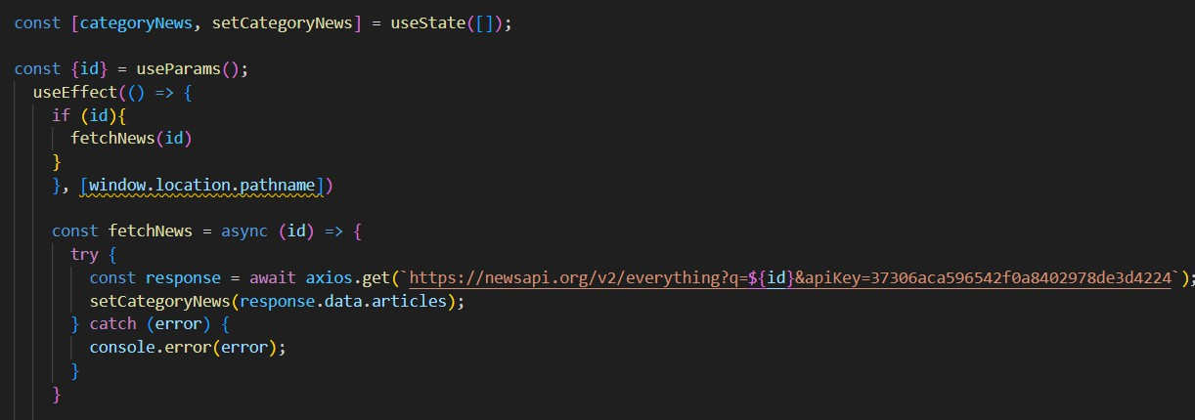

The code snippet shows a function called get_news_articles that fetches news articles from a news API. Here's a breakdown of the code:

*Imports:*

The code starts by importing the requests library. The requests library is a popular Python library for making HTTPrequests.Ifyoudon'talreadyhaveitinstalledinyour project, you can install it using pip install requests.

*API Key:*

The line API_KEY = 'YOUR_API_KEY' defines a variable named API_KEY andassignsita placeholder value 'YOUR_API_KEY'. You should replace this with a placeholder instructing users to replace it with their own API key obtained from the news API provider they want to use.

*FunctionDefinition (get_news_articles):*

Thecodedefinesafunctionnamedget_news_articlesthattakestwoparameters:

* + query: Thisparameterislikelyastringrepresentingthesearchqueryfornews articles.
  + source: This parameter is likely a string representing the news source (e.g.,'bbc-news', 'cnn').

*BuildingtheAPIRequestURL:*

The line url = f'https://newsapi.org/v2/everything?q={query}&apiKey={API_KEY}' constructs the URL for the API request using a formatted string literal (f-string).

TheURLincludesthefollowingparts:

* + - Base URL: https://newsapi.org/v2/everything
    - Queryparameters:
    - q:Thisparameterissettothequeryargumentpassedtothe function.
    - apiKey:Thisparameteris set to the API_KEY variable, which should contain the user's API key.

*MakingtheAPIRequest (requests.get):*

The line response =requests.get(url)sendsaGETrequesttotheAPIURLconstructed earlier. The requests.get function from the requestslibraryisusedtomaketheHTTP request. The response from the API is stored in the response variable.

*ErrorHandling(try...exceptblock):*

* + The try...except block is used to handle potential errors during the API request.
  + The tryblockcontainsthecodethatattemptstofetchdatafromtheAPIusing requests.get(url).
  + The except block handlesanyexceptionsthatmightoccurduringtherequest, such as network errors or invalid APIresponses.Inthiscase,itprintsanerror message to the console using print(f'Error fetching news articles: {e}').

# ProjectExecution:

After completing the code, run the react application by using the command “npm start” or “npm run dev” if you are using vite.js

Herearesomeofthescreenshotsoftheapplication.

## ?Herocomponents

In the hero component, the trending newsarticlesaredisplayed.Itistohighlight them. Apart from that, the search bar is also available to search for various articles and categories.

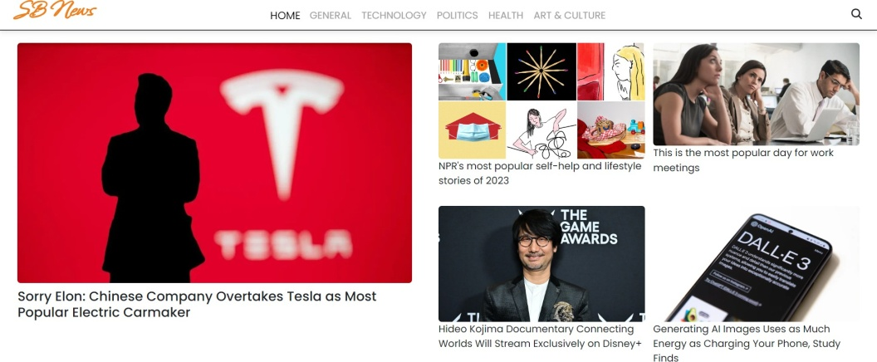

## ?Popularcategories

In the hero component, the trending news articles are displayed. It is to highlight them. Apart from that, the search bar is also available to search for various articles and categories.

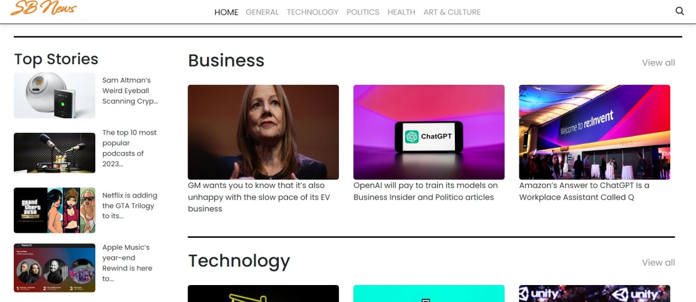

**?Newsletter**

Staying informed is key!This section would act as a magnet for users whowant to stay up-to-date on the latest news.A brief signup form with an email field would be presented, along with aclearcalltoactionbuttonlike"SubscribeNow" or "Get Daily News Updates."With a simple click, users can join the InsightStream community and receive curated news delivered straight to their inbox.

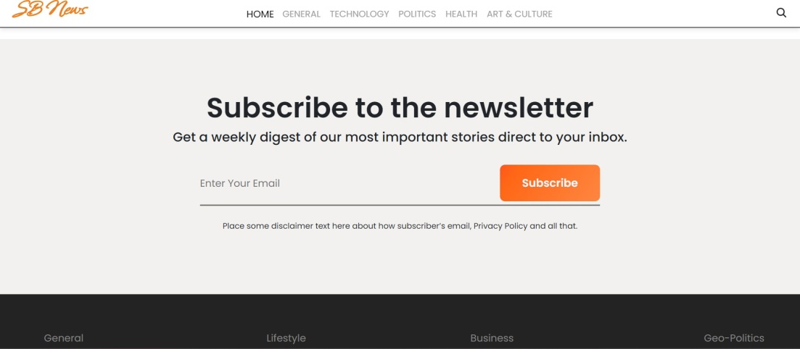

## ?Category/Searchresult page

Finding the news you crave is effortless with InsightStream.This pagedisplaysa neatly organized list of articles matching your chosen category or specificsearch query.Each entry would provide a clear headline, a concise summary, and if available, an image to give you a quick glimpse into the story.To further refine yourexploration,filtersorsortingoptionsmightbeavailable.Imaginenarrowing

down results by date, source, keyword, or other relevant criteria to pinpoint exactly what you're looking for.

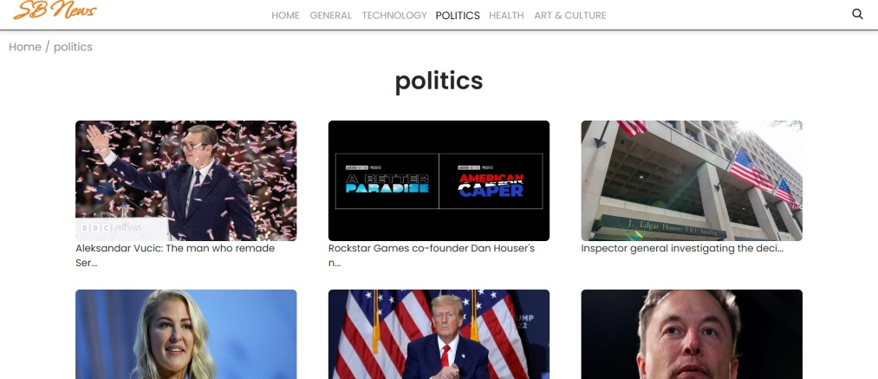

## ? RedirectedArticlepage

This is where you dive deep!The article page proudly displays the complete news story, retrieved directly from the original source.Tokeepyouengagedand exploring related topics, the page might alsosuggestadditionalarticlesbasedon thecurrentstory.Thesesuggestionscanopendoorstoaworldofinterconnected information, allowing you to become a well-rounded news connoisseur.



ProjectDemo link:

https://drive.google.com/file/d/1VxS3bi3yPRiWKeaORKRIXNRMAupmfoUq/view?usp=drivesdk

**\*\*\* Happy coding!! \*\*\***